IBM ASSIGNMENT 2

211419106100

To get Temperature and Humidity Values in Python Code



AIM:

To get temperature and humidity values with random function to a variable and write a condition to detect alarm in high temperature .

SOFTWARE USED :

Python Idle 3.10 (64-bit)

PROGRAM :

import random

import time

while True:

temp=random.randint(0,70)

humd=random.randint(10,60)

if temp > 50 and humd < 20:

print("Temperature=",temp,end=" ")

print("Humidity=",humd,"#########ALARM ON#######")

time.sleep(3)

else:

print("Temperature=",temp,end=" ")

print("Humidity=",humd)

time.sleep(1)

OUTPUT :

temperature= 18 humidity= 61

temperature= 52 humidity= 61

temperature= 4 humidity= 63

temperature= 27 humidity= 38

temperature= 48 humidity= 59

temperature= 17 humidity= 48

temperature= 15 humidity= 46

temperature= 50 humidity= 29

ALARM ON

SIMULATION OUTPUT :

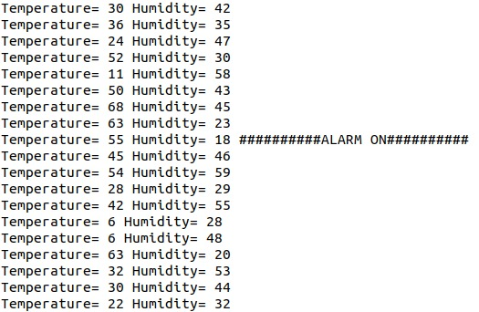

CONDITIONS TO DETECT ALARM IN HIGH TEMPERATURE :

1. Check if the temperature is greater than 40 degrees then inform the fire brigade
2. Check if the temperate is greater than 50 degrees then sound the alarm
3. Else keep the alarm off .

RESULT :

I have successfully coded for temperature and humidity values with random function to a variable and write a condition to detect alarm in high temperature .